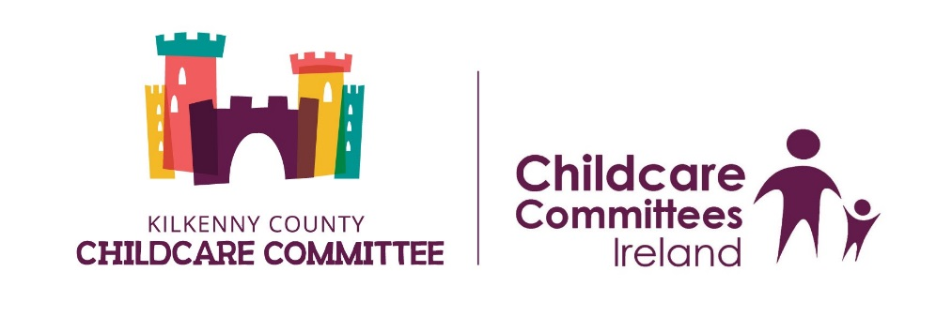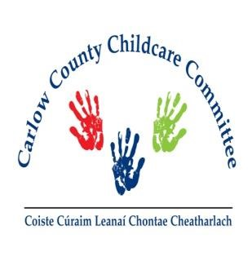

Masters of Arts in Leadership in Early Years Education & Care - Level 9
Part funded by Carlow-Kilkenny Skillnet
Applicants Details
Name of Applicant:

Home Address:

Mobile No:

Email Address:

Employment Details
Place of Employment:

Address:

Telephone No:

Email Address:

Accredited Training that you have participated in over the last 5 years
Please attached a copy of results for all listed below
Course title | Year Obtained
Employment History
You may attach a CV in addition to the information given below
Employer & Address |  | From | To | Job Title | Role (please indicate what rooms you worked in)

LEVEL 9
Why do you wish to pursue this programme – Level 9 Masters of Arts in Leadership in Early Years Education & Care?

I wish to apply for the Masters of Arts in Leadership in Early Years Education & Care (level 9) award with IT Carlow & I give permission to contact my employer in relation to the application if necessary.

Signed: ________________________________ Dated: ________________________

Completed forms (Both) must be sent to
Carlow County Childcare Committee
Marked “Level 9 Application”
Enterprise House
O’Brien Road
Carlow
Or emailed to info@carlowccc.ie

Application Form

PROGRAMME DETAILS STUDENT NO:

Programme Title: Master of Arts in Leadership in Early Years Education and Care.

PERSONAL DETAILS
Please Note: The name you enter will appear on any parchment to which you may be entitled to.
Surname ………………………………..First Name(s)…………………………………..
Address………………………………………………………………………………………
……………………………………………………………….. …………………………….
PPS Number …………………………………………………………………………………
Gender – Male/ Female …………………… Date of birth ………………………………….

Country of Birth…………………………….Citizenship ……………………………………..

Is English/Irish your first Language?
Home Telephone………………………………….Mobile Number …………………………...
Work Number……………………………..Email ……………………………………………..

Next of Kin……………………………..Contact Number…………………………………..

Have you previously been a student in IT Carlow? ……………………………………………
If yes please state course and Year ………………………………………………………..

QUALIFICATIONS
The following information requested is for admission and statistical purposes only and will be treated in the strictest confidence.
Indicate the last Educational Institution attended (i.e Secondary School, Irish University, Irish Institute of Technology, Post Leaving Cert college) ………………………………………

Indicate the Highest Qualification Achieved (i.e. Junior Certificate, Leaving Certificate, FETAC?NCVA, Apprenticeship, Ordinary Degree, Honours Degree, PLC Qualification, Masters) ………………………………………………………………………………….
Please note: proof of qualifications needs to be enclosed when returning application form to the Lifelong Learning Centre. If you are under 23 years of age you will need to provide a copy of the parchment received for any qualifications that you hold
Do you have a Disability/Specific Learning Difficulty? (Yes or No) …………………..
Please Note: that disclosure of a disability and/or specific learning will not adversely affect your application in anyway.
Are you applying for Exemptions? (Yes or No) ………………………………………..
If yes, please request and complete the Exemption Form - available from Lifelong Learning Centre.

APPLICANT DECLARATION
I declare that the information given by me in this application is true and accurate and that if accepted I agree to read and abide by the regulations of Institute of Technology Carlow.
I hereby agree that the Institute may use my photograph in publications of the Institute where they judge this to be the best interest of either myself or the Institute. I understand that the Institute of Technology Carlow will treat all information as confidential and will not disclose such information except as permitted by Law. Other information provided will be held on computer and will only be used for purposes registered under the Data Protection Act.
Signed……………………………………………………..Date …………………………….

