Level 7

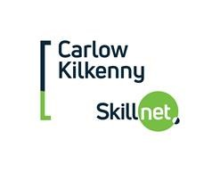
BA In Applied Early Childhood Education and Care Sept 2020.

Application Form

Interviews

Offer of Place

Acceptance of place

Deposits

Fees

Applications for the programme are open from Wednesday 12th February 2020 to 4pm on Friday 6th March 2020. Applicants may be shortlisted based on the information provided in the application forms.
Completed forms (Marked Level 7)
must be sent to:
Carlow Kilkenny Skillnet
Carlow Gateway Business Centre
Athy Road
Carlow
Or emailed to admin@carlowkilkennyskillnet.ie
Please ensure that you complete the form and you MUST send a copy of the transcript of your Level 6 when you receive it

8th April (from 9am – 5pm) in IT Carlow

Before the end of April 2020

Before 5pm 5th May 2020 via email to admin@carlowkilkennyskillnet.ie
Deposits of €500 must be paid with the acceptance of place on Tuesday 12th May 2020. This will secure your place on the programme. All monies must be paid directly to Carlow Kilkenny Skillnet

A second instalment of €250 must be paid by Tuesday 10th August and the final €250 before Tuesday 13th October 2020. All monies must be paid directly to Carlow Kilkenny Skillnet

