



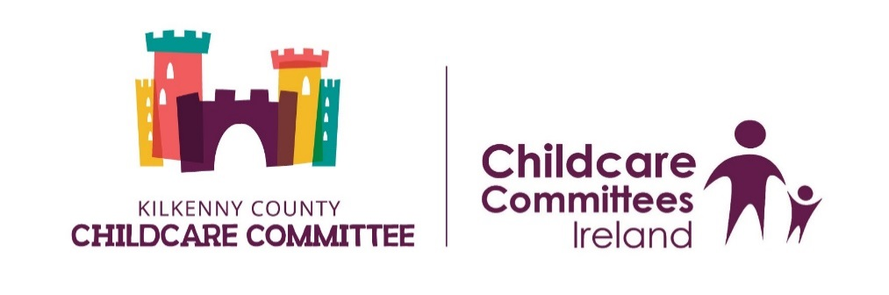

**Bachelor of Arts in Applied Early Childhood Education & Care - Level 7 – Carlow & Kilkenny 2020**

**Programme Code: HRECC_D**

|  |
| --- |
| **Applicants Details** |
| Name of Applicant: |
| Home Address:  County:  Eircode:  Nation:  Citizenship Type: |
| Mobile No: |
| Email Address: |
| P.P.S Number: Gender: |
| Nation of Birth: |
| Nation of Citizenship: |

|  |
| --- |
| **Employment Details** |
| Place of Employment: |
| Address: |
| Telephone No: |
| Email Address: |
| **Qualification**  *DCXXX or 6M2007*  *Please attach results/certificate/parchment of the FULL award* |
| Course title Year Obtained |
|  |

|  |  |  |  |  |  |
| --- | --- | --- | --- | --- | --- |
| **Accredited Training that you have participated in over the last 5 years**  *Please attached a copy of results for all listed below* | | | | | |
| Course title Year Obtained | | | | | |
|  | | | | | |
|  | | | | | |
|  | | | | | |
|  | | | | | |
|  | | | | | |
|  | | | | | |
| **Employment History**  ***You may attach a CV in addition to the information given below*** | | | | | |
| Employer & Address | From | To | Job Title | Role (please indicate what rooms you worked in) |
|  |  |  |  |  |
|  |  |  |  |  |

|  |
| --- |
| **LEVEL 7** |
| Why do you wish to pursue this programme –Level 7 in Early Childhood Education & Care? |

I wish to apply for the BA Applied Early Childhood Education & Care (level 7) award with IT Carlow & I give permission to IT Carlow to contact my employer in relation to the application if necessary.

Signed: ________________________________ Dated: ________________________

|  |
| --- |
| **To be completed by your Employer** |
| Is your service currently in receipt of the Higher Capitation for the ECCE Free preschool year?  (please circle)  Yes No |
| How many staff in your service work directly with children? |
| How many have ECCE Level 7+? |
| How many ECCE rooms operate in your service and at what times?  **Room Session Time** |
| Is the person applying for this training programme (Level 7) currently working in the ECCE room? (please circle)  Yes No |
| Will they be working in the ECCE room from Sept 2020? (please circle)  Yes No |
| Signed: Title: |
| Date: |
|  |
| Please return this form (whether you are in Carlow/Kilkenny area) to  **Level 7 Application**  Carlow Kilkenny Skillnet  Carlow Gateway Business Centre  Athy Road  Carlow  before **4pm Friday 6th March 2020** |